يجرى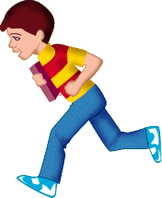 | بنت 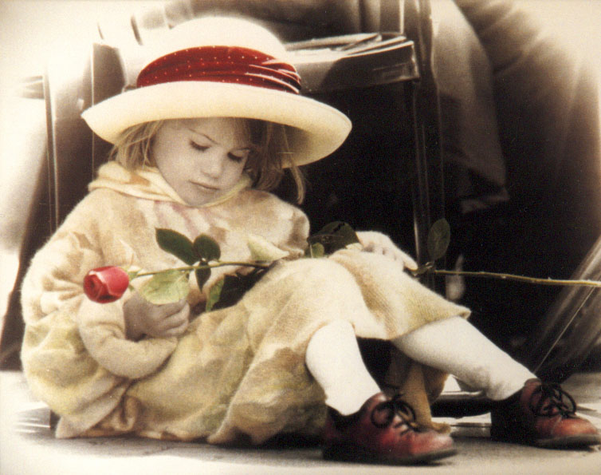 | ولد
run | girl | boy
--------------------------------------------------------------------------------------------------------------------------------------------------------------------------------------------------------------------------------------------------------------------------------------------------------------------

----------------------------------------------------------------------------------------------------------------------------------------------------------------------------------------------------------------------------------------------------------------------------------------------------------------------

----------------------------------------------------------------------------------------------------------------------------------------------------------------------------------------------------------------------------------------------------------------------------------------------------------------------

----------------------------------------------------------------------------------------------------------------------------------------------------------------------------------------------------------------------------------------------------------------------------------------------------------------------

----------------------------------------------------------------------------------------------------------------------------------------------------------------------------------------------------------------------------------------------------------------------------------------------------------------------

----------------------------------------------------------------------------------------------------------------------------------------------------------------------------------------------------------------------------------------------------------------------------------------------------------------------

----------------------------------------------------------------------------------------------------------------------------------------------------------------------------------------------------------------------------------------------------------------------------------------------------------------------

----------------------------------------------------------------------------------------------------------------------------------------------------------------------------------------------------------------------------------------------------------------------------------------------------------------------

----------------------------------------------------------------------------------------------------------------------------------------------------------------------------------------------------------------------------------------------------------------------------------------------------------------------

----------------------------------------------------------------------------------------------------------------------------------------------------------------------------------------------------------------------------------------------------------------------------------------------------------------------

----------------------------------------------------------------------------------------------------------------------------------------------------------------------------------------------------------------------------------------------------------------------------------------------------------------------

----------------------------------------------------------------------------------------------------------------------------------------------------------------------------------------------------------------------------------------------------------------------------------------------------------------------

----------------------------------------------------------------------------------------------------------------------------------------------------------------------------------------------------------------------------------------------------------------------------------------------------------------------

----------------------------------------------------------------------------------------------------------------------------------------------------------------------------------------------------------------------------------------------------------------------------------------------------------------------

----------------------------------------------------------------------------------------------------------------------------------------------------------------------------------------------------------------------------------------------------------------------------------------------------------------------

----------------------------------------------------------------------------------------------------------------------------------------------------------------------------------------------------------------------------------------------------------------------------------------------------------------------

----------------------------------------------------------------------------------------------------------------------------------------------------------------------------------------------------------------------------------------------------------------------------------------------------------------------

----------------------------------------------------------------------------------------------------------------------------------------------------------------------------------------------------------------------------------------------------------------------------------------------------------------------

----------------------------------------------------------------------------------------------------------------------------------------------------------------------------------------------------------------------------------------------------------------------------------------------------------------------

----------------------------------------------------------------------------------------------------------------------------------------------------------------------------------------------------------------------------------------------------------------------------------------------------------------------

----------------------------------------------------------------------------------------------------------------------------------------------------------------------------------------------------------------------------------------------------------------------------------------------------------------------

----------------------------------------------------------------------------------------------------------------------------------------------------------------------------------------------------------------------------------------------------------------------------------------------------------------------
1

 | 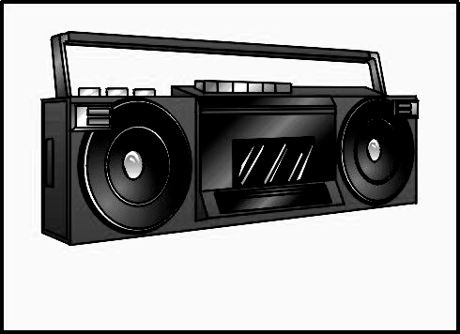راديو |  | ارنب 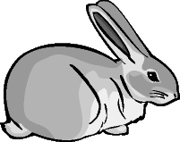 |  | شجرة 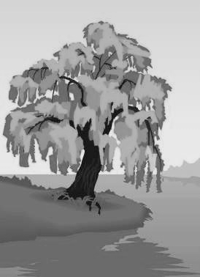
radio |  | rabbit |  | tree
--------------------------------------------------------------------------------------------------------------------------------------------------------------------------------------------------------------------------------------------------------------------------------------------------------------------

----------------------------------------------------------------------------------------------------------------------------------------------------------------------------------------------------------------------------------------------------------------------------------------------------------------------

----------------------------------------------------------------------------------------------------------------------------------------------------------------------------------------------------------------------------------------------------------------------------------------------------------------------

----------------------------------------------------------------------------------------------------------------------------------------------------------------------------------------------------------------------------------------------------------------------------------------------------------------------

----------------------------------------------------------------------------------------------------------------------------------------------------------------------------------------------------------------------------------------------------------------------------------------------------------------------

----------------------------------------------------------------------------------------------------------------------------------------------------------------------------------------------------------------------------------------------------------------------------------------------------------------------

----------------------------------------------------------------------------------------------------------------------------------------------------------------------------------------------------------------------------------------------------------------------------------------------------------------------

----------------------------------------------------------------------------------------------------------------------------------------------------------------------------------------------------------------------------------------------------------------------------------------------------------------------

----------------------------------------------------------------------------------------------------------------------------------------------------------------------------------------------------------------------------------------------------------------------------------------------------------------------

----------------------------------------------------------------------------------------------------------------------------------------------------------------------------------------------------------------------------------------------------------------------------------------------------------------------

----------------------------------------------------------------------------------------------------------------------------------------------------------------------------------------------------------------------------------------------------------------------------------------------------------------------

----------------------------------------------------------------------------------------------------------------------------------------------------------------------------------------------------------------------------------------------------------------------------------------------------------------------

----------------------------------------------------------------------------------------------------------------------------------------------------------------------------------------------------------------------------------------------------------------------------------------------------------------------

----------------------------------------------------------------------------------------------------------------------------------------------------------------------------------------------------------------------------------------------------------------------------------------------------------------------

----------------------------------------------------------------------------------------------------------------------------------------------------------------------------------------------------------------------------------------------------------------------------------------------------------------------

----------------------------------------------------------------------------------------------------------------------------------------------------------------------------------------------------------------------------------------------------------------------------------------------------------------------

----------------------------------------------------------------------------------------------------------------------------------------------------------------------------------------------------------------------------------------------------------------------------------------------------------------------

----------------------------------------------------------------------------------------------------------------------------------------------------------------------------------------------------------------------------------------------------------------------------------------------------------------------

----------------------------------------------------------------------------------------------------------------------------------------------------------------------------------------------------------------------------------------------------------------------------------------------------------------------

----------------------------------------------------------------------------------------------------------------------------------------------------------------------------------------------------------------------------------------------------------------------------------------------------------------------

----------------------------------------------------------------------------------------------------------------------------------------------------------------------------------------------------------------------------------------------------------------------------------------------------------------------

--------------------------------------------------------------------------------------------------------------------------------------------------------------------------------------------------------------------------------------------------------------------------------------------------- 2
شنطة  | قلم رصاص  | قلم جاف 
bag | pencil | pen
--------------------------------------------------------------------------------------------------------------------------------------------------------------------------------------------------------------------------------------------------------------------------------------------------------------------

----------------------------------------------------------------------------------------------------------------------------------------------------------------------------------------------------------------------------------------------------------------------------------------------------------------------

----------------------------------------------------------------------------------------------------------------------------------------------------------------------------------------------------------------------------------------------------------------------------------------------------------------------

----------------------------------------------------------------------------------------------------------------------------------------------------------------------------------------------------------------------------------------------------------------------------------------------------------------------

----------------------------------------------------------------------------------------------------------------------------------------------------------------------------------------------------------------------------------------------------------------------------------------------------------------------

----------------------------------------------------------------------------------------------------------------------------------------------------------------------------------------------------------------------------------------------------------------------------------------------------------------------

----------------------------------------------------------------------------------------------------------------------------------------------------------------------------------------------------------------------------------------------------------------------------------------------------------------------

----------------------------------------------------------------------------------------------------------------------------------------------------------------------------------------------------------------------------------------------------------------------------------------------------------------------

----------------------------------------------------------------------------------------------------------------------------------------------------------------------------------------------------------------------------------------------------------------------------------------------------------------------

----------------------------------------------------------------------------------------------------------------------------------------------------------------------------------------------------------------------------------------------------------------------------------------------------------------------

----------------------------------------------------------------------------------------------------------------------------------------------------------------------------------------------------------------------------------------------------------------------------------------------------------------------

----------------------------------------------------------------------------------------------------------------------------------------------------------------------------------------------------------------------------------------------------------------------------------------------------------------------

----------------------------------------------------------------------------------------------------------------------------------------------------------------------------------------------------------------------------------------------------------------------------------------------------------------------

----------------------------------------------------------------------------------------------------------------------------------------------------------------------------------------------------------------------------------------------------------------------------------------------------------------------

----------------------------------------------------------------------------------------------------------------------------------------------------------------------------------------------------------------------------------------------------------------------------------------------------------------------

----------------------------------------------------------------------------------------------------------------------------------------------------------------------------------------------------------------------------------------------------------------------------------------------------------------------

----------------------------------------------------------------------------------------------------------------------------------------------------------------------------------------------------------------------------------------------------------------------------------------------------------------------

----------------------------------------------------------------------------------------------------------------------------------------------------------------------------------------------------------------------------------------------------------------------------------------------------------------------

----------------------------------------------------------------------------------------------------------------------------------------------------------------------------------------------------------------------------------------------------------------------------------------------------------------------

----------------------------------------------------------------------------------------------------------------------------------------------------------------------------------------------------------------------------------------------------------------------------------------------------------------------

----------------------------------------------------------------------------------------------------------------------------------------------------------------------------------------------------------------------------------------------------------------------------------------------------------------------

----------------------------------------------------------------------------------------------------------------------------------------------------------------------------------------------------------------------------------------------------------------------------------------------------------------------

3
اثنان | واحد | يــــد 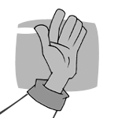
two | one | hand
--------------------------------------------------------------------------------------------------------------------------------------------------------------------------------------------------------------------------------------------------------------------------------------------------------------------

----------------------------------------------------------------------------------------------------------------------------------------------------------------------------------------------------------------------------------------------------------------------------------------------------------------------

----------------------------------------------------------------------------------------------------------------------------------------------------------------------------------------------------------------------------------------------------------------------------------------------------------------------

----------------------------------------------------------------------------------------------------------------------------------------------------------------------------------------------------------------------------------------------------------------------------------------------------------------------

----------------------------------------------------------------------------------------------------------------------------------------------------------------------------------------------------------------------------------------------------------------------------------------------------------------------

----------------------------------------------------------------------------------------------------------------------------------------------------------------------------------------------------------------------------------------------------------------------------------------------------------------------

----------------------------------------------------------------------------------------------------------------------------------------------------------------------------------------------------------------------------------------------------------------------------------------------------------------------

----------------------------------------------------------------------------------------------------------------------------------------------------------------------------------------------------------------------------------------------------------------------------------------------------------------------

----------------------------------------------------------------------------------------------------------------------------------------------------------------------------------------------------------------------------------------------------------------------------------------------------------------------

----------------------------------------------------------------------------------------------------------------------------------------------------------------------------------------------------------------------------------------------------------------------------------------------------------------------

----------------------------------------------------------------------------------------------------------------------------------------------------------------------------------------------------------------------------------------------------------------------------------------------------------------------

----------------------------------------------------------------------------------------------------------------------------------------------------------------------------------------------------------------------------------------------------------------------------------------------------------------------

----------------------------------------------------------------------------------------------------------------------------------------------------------------------------------------------------------------------------------------------------------------------------------------------------------------------

----------------------------------------------------------------------------------------------------------------------------------------------------------------------------------------------------------------------------------------------------------------------------------------------------------------------

----------------------------------------------------------------------------------------------------------------------------------------------------------------------------------------------------------------------------------------------------------------------------------------------------------------------

----------------------------------------------------------------------------------------------------------------------------------------------------------------------------------------------------------------------------------------------------------------------------------------------------------------------

----------------------------------------------------------------------------------------------------------------------------------------------------------------------------------------------------------------------------------------------------------------------------------------------------------------------

----------------------------------------------------------------------------------------------------------------------------------------------------------------------------------------------------------------------------------------------------------------------------------------------------------------------

----------------------------------------------------------------------------------------------------------------------------------------------------------------------------------------------------------------------------------------------------------------------------------------------------------------------

----------------------------------------------------------------------------------------------------------------------------------------------------------------------------------------------------------------------------------------------------------------------------------------------------------------------

----------------------------------------------------------------------------------------------------------------------------------------------------------------------------------------------------------------------------------------------------------------------------------------------------------------------

----------------------------------------------------------------------------------------------------------------------------------------------------------------------------------------------------------------------------------------------------------------------------------------------------------------------
4
اُذن 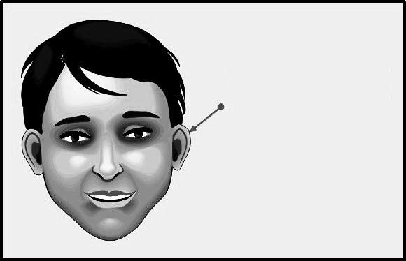 | عين  | وجه 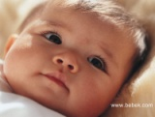
ear | eye | face
--------------------------------------------------------------------------------------------------------------------------------------------------------------------------------------------------------------------------------------------------------------------------------------------------------------------

----------------------------------------------------------------------------------------------------------------------------------------------------------------------------------------------------------------------------------------------------------------------------------------------------------------------

----------------------------------------------------------------------------------------------------------------------------------------------------------------------------------------------------------------------------------------------------------------------------------------------------------------------

----------------------------------------------------------------------------------------------------------------------------------------------------------------------------------------------------------------------------------------------------------------------------------------------------------------------

----------------------------------------------------------------------------------------------------------------------------------------------------------------------------------------------------------------------------------------------------------------------------------------------------------------------

----------------------------------------------------------------------------------------------------------------------------------------------------------------------------------------------------------------------------------------------------------------------------------------------------------------------

----------------------------------------------------------------------------------------------------------------------------------------------------------------------------------------------------------------------------------------------------------------------------------------------------------------------

----------------------------------------------------------------------------------------------------------------------------------------------------------------------------------------------------------------------------------------------------------------------------------------------------------------------

----------------------------------------------------------------------------------------------------------------------------------------------------------------------------------------------------------------------------------------------------------------------------------------------------------------------

----------------------------------------------------------------------------------------------------------------------------------------------------------------------------------------------------------------------------------------------------------------------------------------------------------------------

----------------------------------------------------------------------------------------------------------------------------------------------------------------------------------------------------------------------------------------------------------------------------------------------------------------------

----------------------------------------------------------------------------------------------------------------------------------------------------------------------------------------------------------------------------------------------------------------------------------------------------------------------

----------------------------------------------------------------------------------------------------------------------------------------------------------------------------------------------------------------------------------------------------------------------------------------------------------------------

----------------------------------------------------------------------------------------------------------------------------------------------------------------------------------------------------------------------------------------------------------------------------------------------------------------------

----------------------------------------------------------------------------------------------------------------------------------------------------------------------------------------------------------------------------------------------------------------------------------------------------------------------

----------------------------------------------------------------------------------------------------------------------------------------------------------------------------------------------------------------------------------------------------------------------------------------------------------------------

----------------------------------------------------------------------------------------------------------------------------------------------------------------------------------------------------------------------------------------------------------------------------------------------------------------------

----------------------------------------------------------------------------------------------------------------------------------------------------------------------------------------------------------------------------------------------------------------------------------------------------------------------

----------------------------------------------------------------------------------------------------------------------------------------------------------------------------------------------------------------------------------------------------------------------------------------------------------------------

----------------------------------------------------------------------------------------------------------------------------------------------------------------------------------------------------------------------------------------------------------------------------------------------------------------------

----------------------------------------------------------------------------------------------------------------------------------------------------------------------------------------------------------------------------------------------------------------------------------------------------------------------
5

أنف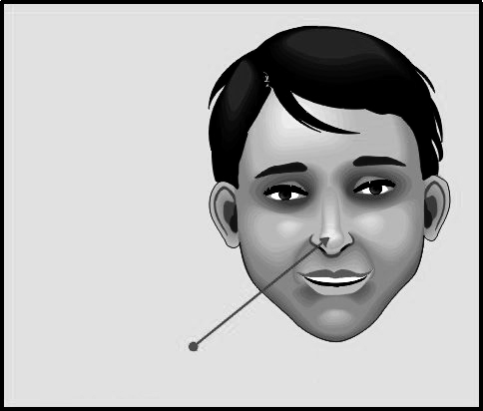 | أصبع القدم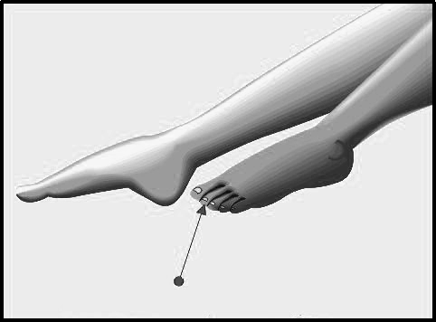 | يـــد 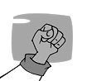
nose | toe | hand
--------------------------------------------------------------------------------------------------------------------------------------------------------------------------------------------------------------------------------------------------------------------------------------------------------------------

----------------------------------------------------------------------------------------------------------------------------------------------------------------------------------------------------------------------------------------------------------------------------------------------------------------------

----------------------------------------------------------------------------------------------------------------------------------------------------------------------------------------------------------------------------------------------------------------------------------------------------------------------

----------------------------------------------------------------------------------------------------------------------------------------------------------------------------------------------------------------------------------------------------------------------------------------------------------------------

----------------------------------------------------------------------------------------------------------------------------------------------------------------------------------------------------------------------------------------------------------------------------------------------------------------------

----------------------------------------------------------------------------------------------------------------------------------------------------------------------------------------------------------------------------------------------------------------------------------------------------------------------

----------------------------------------------------------------------------------------------------------------------------------------------------------------------------------------------------------------------------------------------------------------------------------------------------------------------

----------------------------------------------------------------------------------------------------------------------------------------------------------------------------------------------------------------------------------------------------------------------------------------------------------------------

----------------------------------------------------------------------------------------------------------------------------------------------------------------------------------------------------------------------------------------------------------------------------------------------------------------------

----------------------------------------------------------------------------------------------------------------------------------------------------------------------------------------------------------------------------------------------------------------------------------------------------------------------

----------------------------------------------------------------------------------------------------------------------------------------------------------------------------------------------------------------------------------------------------------------------------------------------------------------------

----------------------------------------------------------------------------------------------------------------------------------------------------------------------------------------------------------------------------------------------------------------------------------------------------------------------

----------------------------------------------------------------------------------------------------------------------------------------------------------------------------------------------------------------------------------------------------------------------------------------------------------------------

----------------------------------------------------------------------------------------------------------------------------------------------------------------------------------------------------------------------------------------------------------------------------------------------------------------------

----------------------------------------------------------------------------------------------------------------------------------------------------------------------------------------------------------------------------------------------------------------------------------------------------------------------

----------------------------------------------------------------------------------------------------------------------------------------------------------------------------------------------------------------------------------------------------------------------------------------------------------------------

----------------------------------------------------------------------------------------------------------------------------------------------------------------------------------------------------------------------------------------------------------------------------------------------------------------------

----------------------------------------------------------------------------------------------------------------------------------------------------------------------------------------------------------------------------------------------------------------------------------------------------------------------

----------------------------------------------------------------------------------------------------------------------------------------------------------------------------------------------------------------------------------------------------------------------------------------------------------------------

----------------------------------------------------------------------------------------------------------------------------------------------------------------------------------------------------------------------------------------------------------------------------------------------------------------------

----------------------------------------------------------------------------------------------------------------------------------------------------------------------------------------------------------------------------------------------------------------------------------------------------------------------

6
10 10 | أخضر | أحمر
Ten | Green | Red

--------------------------------------------------------------------------------------------------------------------------------------------------------------------------------------------------------------------------------------------------------------------------------------------------------------------

----------------------------------------------------------------------------------------------------------------------------------------------------------------------------------------------------------------------------------------------------------------------------------------------------------------------

----------------------------------------------------------------------------------------------------------------------------------------------------------------------------------------------------------------------------------------------------------------------------------------------------------------------

----------------------------------------------------------------------------------------------------------------------------------------------------------------------------------------------------------------------------------------------------------------------------------------------------------------------

----------------------------------------------------------------------------------------------------------------------------------------------------------------------------------------------------------------------------------------------------------------------------------------------------------------------

----------------------------------------------------------------------------------------------------------------------------------------------------------------------------------------------------------------------------------------------------------------------------------------------------------------------

----------------------------------------------------------------------------------------------------------------------------------------------------------------------------------------------------------------------------------------------------------------------------------------------------------------------

----------------------------------------------------------------------------------------------------------------------------------------------------------------------------------------------------------------------------------------------------------------------------------------------------------------------

----------------------------------------------------------------------------------------------------------------------------------------------------------------------------------------------------------------------------------------------------------------------------------------------------------------------

----------------------------------------------------------------------------------------------------------------------------------------------------------------------------------------------------------------------------------------------------------------------------------------------------------------------

----------------------------------------------------------------------------------------------------------------------------------------------------------------------------------------------------------------------------------------------------------------------------------------------------------------------

----------------------------------------------------------------------------------------------------------------------------------------------------------------------------------------------------------------------------------------------------------------------------------------------------------------------

----------------------------------------------------------------------------------------------------------------------------------------------------------------------------------------------------------------------------------------------------------------------------------------------------------------------

----------------------------------------------------------------------------------------------------------------------------------------------------------------------------------------------------------------------------------------------------------------------------------------------------------------------

----------------------------------------------------------------------------------------------------------------------------------------------------------------------------------------------------------------------------------------------------------------------------------------------------------------------

----------------------------------------------------------------------------------------------------------------------------------------------------------------------------------------------------------------------------------------------------------------------------------------------------------------------

----------------------------------------------------------------------------------------------------------------------------------------------------------------------------------------------------------------------------------------------------------------------------------------------------------------------

----------------------------------------------------------------------------------------------------------------------------------------------------------------------------------------------------------------------------------------------------------------------------------------------------------------------

----------------------------------------------------------------------------------------------------------------------------------------------------------------------------------------------------------------------------------------------------------------------------------------------------------------------

----------------------------------------------------------------------------------------------------------------------------------------------------------------------------------------------------------------------------------------------------------------------------------------------------------------------

----------------------------------------------------------------------------------------------------------------------------------------------------------------------------------------------------------------------------------------------------------------------------------------------------------------------

----------------------------------------------------------------------------------------------------------------------------------------------------------------------------------------------------------------------------------------------------------------------------------------------------------------------
7

يرسم | جزرة 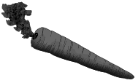 | فم 
draw | carrot | mouth
--------------------------------------------------------------------------------------------------------------------------------------------------------------------------------------------------------------------------------------------------------------------------------------------------------------------

----------------------------------------------------------------------------------------------------------------------------------------------------------------------------------------------------------------------------------------------------------------------------------------------------------------------

----------------------------------------------------------------------------------------------------------------------------------------------------------------------------------------------------------------------------------------------------------------------------------------------------------------------

----------------------------------------------------------------------------------------------------------------------------------------------------------------------------------------------------------------------------------------------------------------------------------------------------------------------

----------------------------------------------------------------------------------------------------------------------------------------------------------------------------------------------------------------------------------------------------------------------------------------------------------------------

----------------------------------------------------------------------------------------------------------------------------------------------------------------------------------------------------------------------------------------------------------------------------------------------------------------------

----------------------------------------------------------------------------------------------------------------------------------------------------------------------------------------------------------------------------------------------------------------------------------------------------------------------

----------------------------------------------------------------------------------------------------------------------------------------------------------------------------------------------------------------------------------------------------------------------------------------------------------------------

----------------------------------------------------------------------------------------------------------------------------------------------------------------------------------------------------------------------------------------------------------------------------------------------------------------------

----------------------------------------------------------------------------------------------------------------------------------------------------------------------------------------------------------------------------------------------------------------------------------------------------------------------

----------------------------------------------------------------------------------------------------------------------------------------------------------------------------------------------------------------------------------------------------------------------------------------------------------------------

----------------------------------------------------------------------------------------------------------------------------------------------------------------------------------------------------------------------------------------------------------------------------------------------------------------------

----------------------------------------------------------------------------------------------------------------------------------------------------------------------------------------------------------------------------------------------------------------------------------------------------------------------

----------------------------------------------------------------------------------------------------------------------------------------------------------------------------------------------------------------------------------------------------------------------------------------------------------------------

----------------------------------------------------------------------------------------------------------------------------------------------------------------------------------------------------------------------------------------------------------------------------------------------------------------------

----------------------------------------------------------------------------------------------------------------------------------------------------------------------------------------------------------------------------------------------------------------------------------------------------------------------

----------------------------------------------------------------------------------------------------------------------------------------------------------------------------------------------------------------------------------------------------------------------------------------------------------------------

----------------------------------------------------------------------------------------------------------------------------------------------------------------------------------------------------------------------------------------------------------------------------------------------------------------------

----------------------------------------------------------------------------------------------------------------------------------------------------------------------------------------------------------------------------------------------------------------------------------------------------------------------

----------------------------------------------------------------------------------------------------------------------------------------------------------------------------------------------------------------------------------------------------------------------------------------------------------------------

----------------------------------------------------------------------------------------------------------------------------------------------------------------------------------------------------------------------------------------------------------------------------------------------------------------------

----------------------------------------------------------------------------------------------------------------------------------------------------------------------------------------------------------------------------------------------------------------------------------------------------------------------
8
فراشة 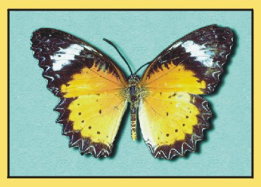 | سبورة | كتاب 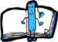 |  شنطة
butterfly | board | book | bag

----------------------------------------------------------------------------------------------------------------------------------------------------------------------------------------------------------------------------------------------------------------------------------------------------------------------

----------------------------------------------------------------------------------------------------------------------------------------------------------------------------------------------------------------------------------------------------------------------------------------------------------------------

---------------------------------------------------------------------------------------------------------------------------------------------------------------------------------------------------------------------------------------------------------------------------------------------------------------------

----------------------------------------------------------------------------------------------------------------------------------------------------------------------------------------------------------------------------------------------------------------------------------------------------------------------

----------------------------------------------------------------------------------------------------------------------------------------------------------------------------------------------------------------------------------------------------------------------------------------------------------------------

---------------------------------------------------------------------------------------------------------------------------------------------------------------------------------------------------------------------------------------------------------------------------------------------------------------------

----------------------------------------------------------------------------------------------------------------------------------------------------------------------------------------------------------------------------------------------------------------------------------------------------------------------

----------------------------------------------------------------------------------------------------------------------------------------------------------------------------------------------------------------------------------------------------------------------------------------------------------------------

---------------------------------------------------------------------------------------------------------------------------------------------------------------------------------------------------------------------------------------------------------------------------------------------------------------------

----------------------------------------------------------------------------------------------------------------------------------------------------------------------------------------------------------------------------------------------------------------------------------------------------------------------

----------------------------------------------------------------------------------------------------------------------------------------------------------------------------------------------------------------------------------------------------------------------------------------------------------------------

---------------------------------------------------------------------------------------------------------------------------------------------------------------------------------------------------------------------------------------------------------------------------------------------------------------------

----------------------------------------------------------------------------------------------------------------------------------------------------------------------------------------------------------------------------------------------------------------------------------------------------------------------

----------------------------------------------------------------------------------------------------------------------------------------------------------------------------------------------------------------------------------------------------------------------------------------------------------------------

---------------------------------------------------------------------------------------------------------------------------------------------------------------------------------------------------------------------------------------------------------------------------------------------------------------------

----------------------------------------------------------------------------------------------------------------------------------------------------------------------------------------------------------------------------------------------------------------------------------------------------------------------

----------------------------------------------------------------------------------------------------------------------------------------------------------------------------------------------------------------------------------------------------------------------------------------------------------------------

---------------------------------------------------------------------------------------------------------------------------------------------------------------------------------------------------------------------------------------------------------------------------------------------------------------------

----------------------------------------------------------------------------------------------------------------------------------------------------------------------------------------------------------------------------------------------------------------------------------------------------------------------

----------------------------------------------------------------------------------------------------------------------------------------------------------------------------------------------------------------------------------------------------------------------------------------------------------------------

---------------------------------------------------------------------------------------------------------------------------------------------------------------------------------------------------------------------------------------------------------------------------------------------------------------------

----------------------------------------------------------------------------------------------------------------------------------------------------------------------------------------------------------------------------------------------------------------------------------------------- 9
استاذة | سمكة 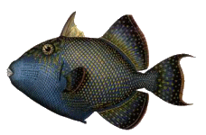 | قطة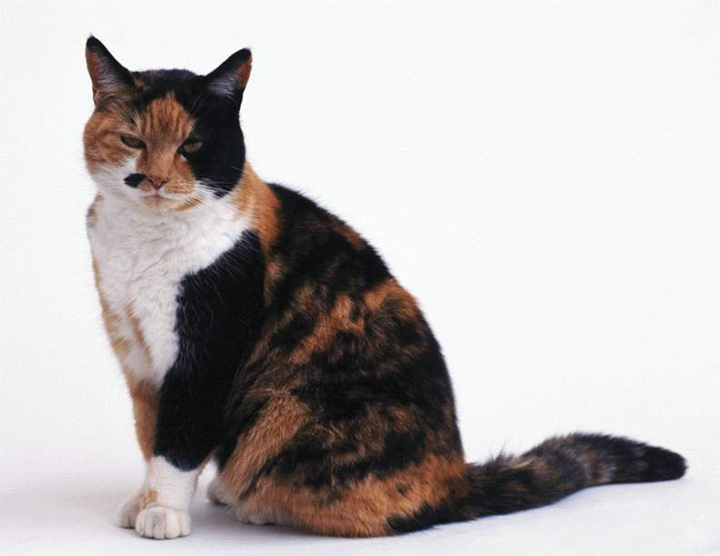 | نحلة 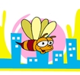
miss | Fish | cat | bee
----------------------------------------------------------------------------------------------------------------------------------------------------------------------------------------------------------------------------------------------------------------------------------------------------------------------

----------------------------------------------------------------------------------------------------------------------------------------------------------------------------------------------------------------------------------------------------------------------------------------------------------------------

---------------------------------------------------------------------------------------------------------------------------------------------------------------------------------------------------------------------------------------------------------------------------------------------------------------------

----------------------------------------------------------------------------------------------------------------------------------------------------------------------------------------------------------------------------------------------------------------------------------------------------------------------

----------------------------------------------------------------------------------------------------------------------------------------------------------------------------------------------------------------------------------------------------------------------------------------------------------------------

---------------------------------------------------------------------------------------------------------------------------------------------------------------------------------------------------------------------------------------------------------------------------------------------------------------------

----------------------------------------------------------------------------------------------------------------------------------------------------------------------------------------------------------------------------------------------------------------------------------------------------------------------

----------------------------------------------------------------------------------------------------------------------------------------------------------------------------------------------------------------------------------------------------------------------------------------------------------------------

---------------------------------------------------------------------------------------------------------------------------------------------------------------------------------------------------------------------------------------------------------------------------------------------------------------------

----------------------------------------------------------------------------------------------------------------------------------------------------------------------------------------------------------------------------------------------------------------------------------------------------------------------

----------------------------------------------------------------------------------------------------------------------------------------------------------------------------------------------------------------------------------------------------------------------------------------------------------------------

---------------------------------------------------------------------------------------------------------------------------------------------------------------------------------------------------------------------------------------------------------------------------------------------------------------------

----------------------------------------------------------------------------------------------------------------------------------------------------------------------------------------------------------------------------------------------------------------------------------------------------------------------

----------------------------------------------------------------------------------------------------------------------------------------------------------------------------------------------------------------------------------------------------------------------------------------------------------------------

---------------------------------------------------------------------------------------------------------------------------------------------------------------------------------------------------------------------------------------------------------------------------------------------------------------------

----------------------------------------------------------------------------------------------------------------------------------------------------------------------------------------------------------------------------------------------------------------------------------------------------------------------

----------------------------------------------------------------------------------------------------------------------------------------------------------------------------------------------------------------------------------------------------------------------------------------------------------------------

---------------------------------------------------------------------------------------------------------------------------------------------------------------------------------------------------------------------------------------------------------------------------------------------------------------------

----------------------------------------------------------------------------------------------------------------------------------------------------------------------------------------------------------------------------------------------------------------------------------------------------------------------

----------------------------------------------------------------------------------------------------------------------------------------------------------------------------------------------------------------------------------------------------------------------------------------------------------------------

---------------------------------------------------------------------------------------------------------------------------------------------------------------------------------------------------------------------------------------------------------------------------------------------------------------------

----------------------------------------------------------------------------------------------------------------------------------------------------------------------------------------------------------------------------------------------------------------------------------------------------------------------

10

شباك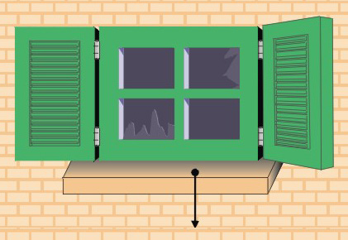 | كاميرا | لا | نعم
window | camera | no | yes
----------------------------------------------------------------------------------------------------------------------------------------------------------------------------------------------------------------------------------------------------------------------------------------------------------------------

----------------------------------------------------------------------------------------------------------------------------------------------------------------------------------------------------------------------------------------------------------------------------------------------------------------------

---------------------------------------------------------------------------------------------------------------------------------------------------------------------------------------------------------------------------------------------------------------------------------------------------------------------

----------------------------------------------------------------------------------------------------------------------------------------------------------------------------------------------------------------------------------------------------------------------------------------------------------------------

----------------------------------------------------------------------------------------------------------------------------------------------------------------------------------------------------------------------------------------------------------------------------------------------------------------------

---------------------------------------------------------------------------------------------------------------------------------------------------------------------------------------------------------------------------------------------------------------------------------------------------------------------

----------------------------------------------------------------------------------------------------------------------------------------------------------------------------------------------------------------------------------------------------------------------------------------------------------------------

----------------------------------------------------------------------------------------------------------------------------------------------------------------------------------------------------------------------------------------------------------------------------------------------------------------------

---------------------------------------------------------------------------------------------------------------------------------------------------------------------------------------------------------------------------------------------------------------------------------------------------------------------

----------------------------------------------------------------------------------------------------------------------------------------------------------------------------------------------------------------------------------------------------------------------------------------------------------------------

----------------------------------------------------------------------------------------------------------------------------------------------------------------------------------------------------------------------------------------------------------------------------------------------------------------------

---------------------------------------------------------------------------------------------------------------------------------------------------------------------------------------------------------------------------------------------------------------------------------------------------------------------

----------------------------------------------------------------------------------------------------------------------------------------------------------------------------------------------------------------------------------------------------------------------------------------------------------------------

----------------------------------------------------------------------------------------------------------------------------------------------------------------------------------------------------------------------------------------------------------------------------------------------------------------------

---------------------------------------------------------------------------------------------------------------------------------------------------------------------------------------------------------------------------------------------------------------------------------------------------------------------

----------------------------------------------------------------------------------------------------------------------------------------------------------------------------------------------------------------------------------------------------------------------------------------------------------------------

----------------------------------------------------------------------------------------------------------------------------------------------------------------------------------------------------------------------------------------------------------------------------------------------------------------------

---------------------------------------------------------------------------------------------------------------------------------------------------------------------------------------------------------------------------------------------------------------------------------------------------------------------

----------------------------------------------------------------------------------------------------------------------------------------------------------------------------------------------------------------------------------------------------------------------------------------------------------------------

----------------------------------------------------------------------------------------------------------------------------------------------------------------------------------------------------------------------------------------------------------------------------------------------------------------------

---------------------------------------------------------------------------------------------------------------------------------------------------------------------------------------------------------------------------------------------------------------------------------------------------------------------

----------------------------------------------------------------------------------------------------------------------------------------------------------------------------------------------------------------------------------------------------------------------------------------------------------------------

11
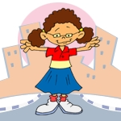  بنت | ولد | و | كمبيوتر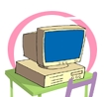
girl | boy | and | computer
----------------------------------------------------------------------------------------------------------------------------------------------------------------------------------------------------------------------------------------------------------------------------------------------------------------------

----------------------------------------------------------------------------------------------------------------------------------------------------------------------------------------------------------------------------------------------------------------------------------------------------------------------

---------------------------------------------------------------------------------------------------------------------------------------------------------------------------------------------------------------------------------------------------------------------------------------------------------------------

----------------------------------------------------------------------------------------------------------------------------------------------------------------------------------------------------------------------------------------------------------------------------------------------------------------------

----------------------------------------------------------------------------------------------------------------------------------------------------------------------------------------------------------------------------------------------------------------------------------------------------------------------

---------------------------------------------------------------------------------------------------------------------------------------------------------------------------------------------------------------------------------------------------------------------------------------------------------------------

----------------------------------------------------------------------------------------------------------------------------------------------------------------------------------------------------------------------------------------------------------------------------------------------------------------------

----------------------------------------------------------------------------------------------------------------------------------------------------------------------------------------------------------------------------------------------------------------------------------------------------------------------

---------------------------------------------------------------------------------------------------------------------------------------------------------------------------------------------------------------------------------------------------------------------------------------------------------------------

----------------------------------------------------------------------------------------------------------------------------------------------------------------------------------------------------------------------------------------------------------------------------------------------------------------------

----------------------------------------------------------------------------------------------------------------------------------------------------------------------------------------------------------------------------------------------------------------------------------------------------------------------

---------------------------------------------------------------------------------------------------------------------------------------------------------------------------------------------------------------------------------------------------------------------------------------------------------------------

----------------------------------------------------------------------------------------------------------------------------------------------------------------------------------------------------------------------------------------------------------------------------------------------------------------------

----------------------------------------------------------------------------------------------------------------------------------------------------------------------------------------------------------------------------------------------------------------------------------------------------------------------

---------------------------------------------------------------------------------------------------------------------------------------------------------------------------------------------------------------------------------------------------------------------------------------------------------------------

----------------------------------------------------------------------------------------------------------------------------------------------------------------------------------------------------------------------------------------------------------------------------------------------------------------------

----------------------------------------------------------------------------------------------------------------------------------------------------------------------------------------------------------------------------------------------------------------------------------------------------------------------

---------------------------------------------------------------------------------------------------------------------------------------------------------------------------------------------------------------------------------------------------------------------------------------------------------------------

----------------------------------------------------------------------------------------------------------------------------------------------------------------------------------------------------------------------------------------------------------------------------------------------------------------------

----------------------------------------------------------------------------------------------------------------------------------------------------------------------------------------------------------------------------------------------------------------------------------------------------------------------

---------------------------------------------------------------------------------------------------------------------------------------------------------------------------------------------------------------------------------------------------------------------------------------------------------------------

----------------------------------------------------------------------------------------------------------------------------------------------------------------------------------------------------------------------------------------------------------------------------------------------------------------------
12

صديق | قلم رصاص | قلم جاف  | تفاحة
Friend | Pencil | pen | apple
----------------------------------------------------------------------------------------------------------------------------------------------------------------------------------------------------------------------------------------------------------------------------------------------------------------------

----------------------------------------------------------------------------------------------------------------------------------------------------------------------------------------------------------------------------------------------------------------------------------------------------------------------

---------------------------------------------------------------------------------------------------------------------------------------------------------------------------------------------------------------------------------------------------------------------------------------------------------------------

----------------------------------------------------------------------------------------------------------------------------------------------------------------------------------------------------------------------------------------------------------------------------------------------------------------------

----------------------------------------------------------------------------------------------------------------------------------------------------------------------------------------------------------------------------------------------------------------------------------------------------------------------

---------------------------------------------------------------------------------------------------------------------------------------------------------------------------------------------------------------------------------------------------------------------------------------------------------------------

----------------------------------------------------------------------------------------------------------------------------------------------------------------------------------------------------------------------------------------------------------------------------------------------------------------------

----------------------------------------------------------------------------------------------------------------------------------------------------------------------------------------------------------------------------------------------------------------------------------------------------------------------

---------------------------------------------------------------------------------------------------------------------------------------------------------------------------------------------------------------------------------------------------------------------------------------------------------------------

----------------------------------------------------------------------------------------------------------------------------------------------------------------------------------------------------------------------------------------------------------------------------------------------------------------------

----------------------------------------------------------------------------------------------------------------------------------------------------------------------------------------------------------------------------------------------------------------------------------------------------------------------

---------------------------------------------------------------------------------------------------------------------------------------------------------------------------------------------------------------------------------------------------------------------------------------------------------------------

----------------------------------------------------------------------------------------------------------------------------------------------------------------------------------------------------------------------------------------------------------------------------------------------------------------------

----------------------------------------------------------------------------------------------------------------------------------------------------------------------------------------------------------------------------------------------------------------------------------------------------------------------

---------------------------------------------------------------------------------------------------------------------------------------------------------------------------------------------------------------------------------------------------------------------------------------------------------------------

----------------------------------------------------------------------------------------------------------------------------------------------------------------------------------------------------------------------------------------------------------------------------------------------------------------------

----------------------------------------------------------------------------------------------------------------------------------------------------------------------------------------------------------------------------------------------------------------------------------------------------------------------

---------------------------------------------------------------------------------------------------------------------------------------------------------------------------------------------------------------------------------------------------------------------------------------------------------------------

----------------------------------------------------------------------------------------------------------------------------------------------------------------------------------------------------------------------------------------------------------------------------------------------------------------------

----------------------------------------------------------------------------------------------------------------------------------------------------------------------------------------------------------------------------------------------------------------------------------------------------------------------

---------------------------------------------------------------------------------------------------------------------------------------------------------------------------------------------------------------------------------------------------------------------------------------------------------------------

----------------------------------------------------------------------------------------------------------------------------------------------------------------------------------------------------------------------------------------------------------------------------------------------------------------------

13
2 | 1 | صغير | منضدة 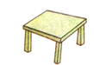
two | one | little | table
----------------------------------------------------------------------------------------------------------------------------------------------------------------------------------------------------------------------------------------------------------------------------------------------------------------------

----------------------------------------------------------------------------------------------------------------------------------------------------------------------------------------------------------------------------------------------------------------------------------------------------------------------

---------------------------------------------------------------------------------------------------------------------------------------------------------------------------------------------------------------------------------------------------------------------------------------------------------------------

----------------------------------------------------------------------------------------------------------------------------------------------------------------------------------------------------------------------------------------------------------------------------------------------------------------------

----------------------------------------------------------------------------------------------------------------------------------------------------------------------------------------------------------------------------------------------------------------------------------------------------------------------

---------------------------------------------------------------------------------------------------------------------------------------------------------------------------------------------------------------------------------------------------------------------------------------------------------------------

----------------------------------------------------------------------------------------------------------------------------------------------------------------------------------------------------------------------------------------------------------------------------------------------------------------------

----------------------------------------------------------------------------------------------------------------------------------------------------------------------------------------------------------------------------------------------------------------------------------------------------------------------

---------------------------------------------------------------------------------------------------------------------------------------------------------------------------------------------------------------------------------------------------------------------------------------------------------------------

----------------------------------------------------------------------------------------------------------------------------------------------------------------------------------------------------------------------------------------------------------------------------------------------------------------------

----------------------------------------------------------------------------------------------------------------------------------------------------------------------------------------------------------------------------------------------------------------------------------------------------------------------

---------------------------------------------------------------------------------------------------------------------------------------------------------------------------------------------------------------------------------------------------------------------------------------------------------------------

----------------------------------------------------------------------------------------------------------------------------------------------------------------------------------------------------------------------------------------------------------------------------------------------------------------------

----------------------------------------------------------------------------------------------------------------------------------------------------------------------------------------------------------------------------------------------------------------------------------------------------------------------

---------------------------------------------------------------------------------------------------------------------------------------------------------------------------------------------------------------------------------------------------------------------------------------------------------------------

----------------------------------------------------------------------------------------------------------------------------------------------------------------------------------------------------------------------------------------------------------------------------------------------------------------------

----------------------------------------------------------------------------------------------------------------------------------------------------------------------------------------------------------------------------------------------------------------------------------------------------------------------

---------------------------------------------------------------------------------------------------------------------------------------------------------------------------------------------------------------------------------------------------------------------------------------------------------------------

----------------------------------------------------------------------------------------------------------------------------------------------------------------------------------------------------------------------------------------------------------------------------------------------------------------------

----------------------------------------------------------------------------------------------------------------------------------------------------------------------------------------------------------------------------------------------------------------------------------------------------------------------

---------------------------------------------------------------------------------------------------------------------------------------------------------------------------------------------------------------------------------------------------------------------------------------------------------------------

----------------------------------------------------------------------------------------------------------------------------------------------------------------------------------------------------------------------------------------------------------------------------------------------------------------------
14

6 | 5 | 4 | 3
Six | five | four | three
----------------------------------------------------------------------------------------------------------------------------------------------------------------------------------------------------------------------------------------------------------------------------------------------------------------------

----------------------------------------------------------------------------------------------------------------------------------------------------------------------------------------------------------------------------------------------------------------------------------------------------------------------

---------------------------------------------------------------------------------------------------------------------------------------------------------------------------------------------------------------------------------------------------------------------------------------------------------------------

----------------------------------------------------------------------------------------------------------------------------------------------------------------------------------------------------------------------------------------------------------------------------------------------------------------------

----------------------------------------------------------------------------------------------------------------------------------------------------------------------------------------------------------------------------------------------------------------------------------------------------------------------

---------------------------------------------------------------------------------------------------------------------------------------------------------------------------------------------------------------------------------------------------------------------------------------------------------------------

----------------------------------------------------------------------------------------------------------------------------------------------------------------------------------------------------------------------------------------------------------------------------------------------------------------------

----------------------------------------------------------------------------------------------------------------------------------------------------------------------------------------------------------------------------------------------------------------------------------------------------------------------

---------------------------------------------------------------------------------------------------------------------------------------------------------------------------------------------------------------------------------------------------------------------------------------------------------------------

----------------------------------------------------------------------------------------------------------------------------------------------------------------------------------------------------------------------------------------------------------------------------------------------------------------------

----------------------------------------------------------------------------------------------------------------------------------------------------------------------------------------------------------------------------------------------------------------------------------------------------------------------

---------------------------------------------------------------------------------------------------------------------------------------------------------------------------------------------------------------------------------------------------------------------------------------------------------------------

----------------------------------------------------------------------------------------------------------------------------------------------------------------------------------------------------------------------------------------------------------------------------------------------------------------------

----------------------------------------------------------------------------------------------------------------------------------------------------------------------------------------------------------------------------------------------------------------------------------------------------------------------

---------------------------------------------------------------------------------------------------------------------------------------------------------------------------------------------------------------------------------------------------------------------------------------------------------------------

----------------------------------------------------------------------------------------------------------------------------------------------------------------------------------------------------------------------------------------------------------------------------------------------------------------------

----------------------------------------------------------------------------------------------------------------------------------------------------------------------------------------------------------------------------------------------------------------------------------------------------------------------

---------------------------------------------------------------------------------------------------------------------------------------------------------------------------------------------------------------------------------------------------------------------------------------------------------------------

----------------------------------------------------------------------------------------------------------------------------------------------------------------------------------------------------------------------------------------------------------------------------------------------------------------------

----------------------------------------------------------------------------------------------------------------------------------------------------------------------------------------------------------------------------------------------------------------------------------------------------------------------

---------------------------------------------------------------------------------------------------------------------------------------------------------------------------------------------------------------------------------------------------------------------------------------------------------------------

----------------------------------------------------------------------------------------------------------------------------------------------------------------------------------------------------------------------------------------------------------------------------------------------------------------------
15

8 | 7 | قطة | كتاب
eight | seven | cat | book
----------------------------------------------------------------------------------------------------------------------------------------------------------------------------------------------------------------------------------------------------------------------------------------------------------------------

----------------------------------------------------------------------------------------------------------------------------------------------------------------------------------------------------------------------------------------------------------------------------------------------------------------------

---------------------------------------------------------------------------------------------------------------------------------------------------------------------------------------------------------------------------------------------------------------------------------------------------------------------

----------------------------------------------------------------------------------------------------------------------------------------------------------------------------------------------------------------------------------------------------------------------------------------------------------------------

----------------------------------------------------------------------------------------------------------------------------------------------------------------------------------------------------------------------------------------------------------------------------------------------------------------------

---------------------------------------------------------------------------------------------------------------------------------------------------------------------------------------------------------------------------------------------------------------------------------------------------------------------

----------------------------------------------------------------------------------------------------------------------------------------------------------------------------------------------------------------------------------------------------------------------------------------------------------------------

----------------------------------------------------------------------------------------------------------------------------------------------------------------------------------------------------------------------------------------------------------------------------------------------------------------------

---------------------------------------------------------------------------------------------------------------------------------------------------------------------------------------------------------------------------------------------------------------------------------------------------------------------

----------------------------------------------------------------------------------------------------------------------------------------------------------------------------------------------------------------------------------------------------------------------------------------------------------------------

----------------------------------------------------------------------------------------------------------------------------------------------------------------------------------------------------------------------------------------------------------------------------------------------------------------------

---------------------------------------------------------------------------------------------------------------------------------------------------------------------------------------------------------------------------------------------------------------------------------------------------------------------

----------------------------------------------------------------------------------------------------------------------------------------------------------------------------------------------------------------------------------------------------------------------------------------------------------------------

----------------------------------------------------------------------------------------------------------------------------------------------------------------------------------------------------------------------------------------------------------------------------------------------------------------------

---------------------------------------------------------------------------------------------------------------------------------------------------------------------------------------------------------------------------------------------------------------------------------------------------------------------

----------------------------------------------------------------------------------------------------------------------------------------------------------------------------------------------------------------------------------------------------------------------------------------------------------------------

----------------------------------------------------------------------------------------------------------------------------------------------------------------------------------------------------------------------------------------------------------------------------------------------------------------------

---------------------------------------------------------------------------------------------------------------------------------------------------------------------------------------------------------------------------------------------------------------------------------------------------------------------

----------------------------------------------------------------------------------------------------------------------------------------------------------------------------------------------------------------------------------------------------------------------------------------------------------------------

----------------------------------------------------------------------------------------------------------------------------------------------------------------------------------------------------------------------------------------------------------------------------------------------------------------------

---------------------------------------------------------------------------------------------------------------------------------------------------------------------------------------------------------------------------------------------------------------------------------------------------------------------

----------------------------------------------------------------------------------------------------------------------------------------------------------------------------------------------------------------------------------------------------------------------------------------------------------------------
16
اللون الأخضر | اللون الأحمر | اللون الأصفر | اللون الأزرق
green | red | yellow | blue
----------------------------------------------------------------------------------------------------------------------------------------------------------------------------------------------------------------------------------------------------------------------------------------------------------------------

----------------------------------------------------------------------------------------------------------------------------------------------------------------------------------------------------------------------------------------------------------------------------------------------------------------------

---------------------------------------------------------------------------------------------------------------------------------------------------------------------------------------------------------------------------------------------------------------------------------------------------------------------

----------------------------------------------------------------------------------------------------------------------------------------------------------------------------------------------------------------------------------------------------------------------------------------------------------------------

----------------------------------------------------------------------------------------------------------------------------------------------------------------------------------------------------------------------------------------------------------------------------------------------------------------------

---------------------------------------------------------------------------------------------------------------------------------------------------------------------------------------------------------------------------------------------------------------------------------------------------------------------

----------------------------------------------------------------------------------------------------------------------------------------------------------------------------------------------------------------------------------------------------------------------------------------------------------------------

----------------------------------------------------------------------------------------------------------------------------------------------------------------------------------------------------------------------------------------------------------------------------------------------------------------------

---------------------------------------------------------------------------------------------------------------------------------------------------------------------------------------------------------------------------------------------------------------------------------------------------------------------

----------------------------------------------------------------------------------------------------------------------------------------------------------------------------------------------------------------------------------------------------------------------------------------------------------------------

----------------------------------------------------------------------------------------------------------------------------------------------------------------------------------------------------------------------------------------------------------------------------------------------------------------------

---------------------------------------------------------------------------------------------------------------------------------------------------------------------------------------------------------------------------------------------------------------------------------------------------------------------

----------------------------------------------------------------------------------------------------------------------------------------------------------------------------------------------------------------------------------------------------------------------------------------------------------------------

----------------------------------------------------------------------------------------------------------------------------------------------------------------------------------------------------------------------------------------------------------------------------------------------------------------------

---------------------------------------------------------------------------------------------------------------------------------------------------------------------------------------------------------------------------------------------------------------------------------------------------------------------

----------------------------------------------------------------------------------------------------------------------------------------------------------------------------------------------------------------------------------------------------------------------------------------------------------------------

----------------------------------------------------------------------------------------------------------------------------------------------------------------------------------------------------------------------------------------------------------------------------------------------------------------------

---------------------------------------------------------------------------------------------------------------------------------------------------------------------------------------------------------------------------------------------------------------------------------------------------------------------

----------------------------------------------------------------------------------------------------------------------------------------------------------------------------------------------------------------------------------------------------------------------------------------------------------------------

----------------------------------------------------------------------------------------------------------------------------------------------------------------------------------------------------------------------------------------------------------------------------------------------------------------------

---------------------------------------------------------------------------------------------------------------------------------------------------------------------------------------------------------------------------------------------------------------------------------------------------------------------

----------------------------------------------------------------------------------------------------------------------------------------------------------------------------------------------------------------------------------------------------------------------------------------------------------------------

17

عنزة | يحب | سرير | سيء
goat | like | bed | bad
----------------------------------------------------------------------------------------------------------------------------------------------------------------------------------------------------------------------------------------------------------------------------------------------------------------------

----------------------------------------------------------------------------------------------------------------------------------------------------------------------------------------------------------------------------------------------------------------------------------------------------------------------

---------------------------------------------------------------------------------------------------------------------------------------------------------------------------------------------------------------------------------------------------------------------------------------------------------------------

----------------------------------------------------------------------------------------------------------------------------------------------------------------------------------------------------------------------------------------------------------------------------------------------------------------------

----------------------------------------------------------------------------------------------------------------------------------------------------------------------------------------------------------------------------------------------------------------------------------------------------------------------

---------------------------------------------------------------------------------------------------------------------------------------------------------------------------------------------------------------------------------------------------------------------------------------------------------------------

----------------------------------------------------------------------------------------------------------------------------------------------------------------------------------------------------------------------------------------------------------------------------------------------------------------------

----------------------------------------------------------------------------------------------------------------------------------------------------------------------------------------------------------------------------------------------------------------------------------------------------------------------

---------------------------------------------------------------------------------------------------------------------------------------------------------------------------------------------------------------------------------------------------------------------------------------------------------------------

----------------------------------------------------------------------------------------------------------------------------------------------------------------------------------------------------------------------------------------------------------------------------------------------------------------------

----------------------------------------------------------------------------------------------------------------------------------------------------------------------------------------------------------------------------------------------------------------------------------------------------------------------

---------------------------------------------------------------------------------------------------------------------------------------------------------------------------------------------------------------------------------------------------------------------------------------------------------------------

----------------------------------------------------------------------------------------------------------------------------------------------------------------------------------------------------------------------------------------------------------------------------------------------------------------------

----------------------------------------------------------------------------------------------------------------------------------------------------------------------------------------------------------------------------------------------------------------------------------------------------------------------

---------------------------------------------------------------------------------------------------------------------------------------------------------------------------------------------------------------------------------------------------------------------------------------------------------------------

----------------------------------------------------------------------------------------------------------------------------------------------------------------------------------------------------------------------------------------------------------------------------------------------------------------------

----------------------------------------------------------------------------------------------------------------------------------------------------------------------------------------------------------------------------------------------------------------------------------------------------------------------

---------------------------------------------------------------------------------------------------------------------------------------------------------------------------------------------------------------------------------------------------------------------------------------------------------------------

----------------------------------------------------------------------------------------------------------------------------------------------------------------------------------------------------------------------------------------------------------------------------------------------------------------------

----------------------------------------------------------------------------------------------------------------------------------------------------------------------------------------------------------------------------------------------------------------------------------------------------------------------

---------------------------------------------------------------------------------------------------------------------------------------------------------------------------------------------------------------------------------------------------------------------------------------------------------------------

----------------------------------------------------------------------------------------------------------------------------------------------------------------------------------------------------------------------------------------------------------------------------------------------------------------------

18

حزين | سعيد | لعبة اليويو | معطف
sad | happy | yoyo | coat
----------------------------------------------------------------------------------------------------------------------------------------------------------------------------------------------------------------------------------------------------------------------------------------------------------------------

----------------------------------------------------------------------------------------------------------------------------------------------------------------------------------------------------------------------------------------------------------------------------------------------------------------------

---------------------------------------------------------------------------------------------------------------------------------------------------------------------------------------------------------------------------------------------------------------------------------------------------------------------

----------------------------------------------------------------------------------------------------------------------------------------------------------------------------------------------------------------------------------------------------------------------------------------------------------------------

----------------------------------------------------------------------------------------------------------------------------------------------------------------------------------------------------------------------------------------------------------------------------------------------------------------------

---------------------------------------------------------------------------------------------------------------------------------------------------------------------------------------------------------------------------------------------------------------------------------------------------------------------

----------------------------------------------------------------------------------------------------------------------------------------------------------------------------------------------------------------------------------------------------------------------------------------------------------------------

----------------------------------------------------------------------------------------------------------------------------------------------------------------------------------------------------------------------------------------------------------------------------------------------------------------------

---------------------------------------------------------------------------------------------------------------------------------------------------------------------------------------------------------------------------------------------------------------------------------------------------------------------

----------------------------------------------------------------------------------------------------------------------------------------------------------------------------------------------------------------------------------------------------------------------------------------------------------------------

----------------------------------------------------------------------------------------------------------------------------------------------------------------------------------------------------------------------------------------------------------------------------------------------------------------------

---------------------------------------------------------------------------------------------------------------------------------------------------------------------------------------------------------------------------------------------------------------------------------------------------------------------

----------------------------------------------------------------------------------------------------------------------------------------------------------------------------------------------------------------------------------------------------------------------------------------------------------------------

----------------------------------------------------------------------------------------------------------------------------------------------------------------------------------------------------------------------------------------------------------------------------------------------------------------------

---------------------------------------------------------------------------------------------------------------------------------------------------------------------------------------------------------------------------------------------------------------------------------------------------------------------

----------------------------------------------------------------------------------------------------------------------------------------------------------------------------------------------------------------------------------------------------------------------------------------------------------------------

----------------------------------------------------------------------------------------------------------------------------------------------------------------------------------------------------------------------------------------------------------------------------------------------------------------------

---------------------------------------------------------------------------------------------------------------------------------------------------------------------------------------------------------------------------------------------------------------------------------------------------------------------

----------------------------------------------------------------------------------------------------------------------------------------------------------------------------------------------------------------------------------------------------------------------------------------------------------------------

----------------------------------------------------------------------------------------------------------------------------------------------------------------------------------------------------------------------------------------------------------------------------------------------------------------------

----------------------------------------------------------------------------------------------------------------------------------------------------------------------------------------------------------------------------------------------------------------------------------------------------------------------

----------------------------------------------------------------------------------------------------------------------------------------------------------------------------------------------------------------------------------------------------------------------------------------------------------------------
19

